USER MANUAL

Requirements:- Python 3.8.1 or <=3.9.0 and Windows 7,8,10 or 11
Step.1) Download the repository
Open command prompt
Git clone https://github.com/aman71711/License_plate_recognition_python.git
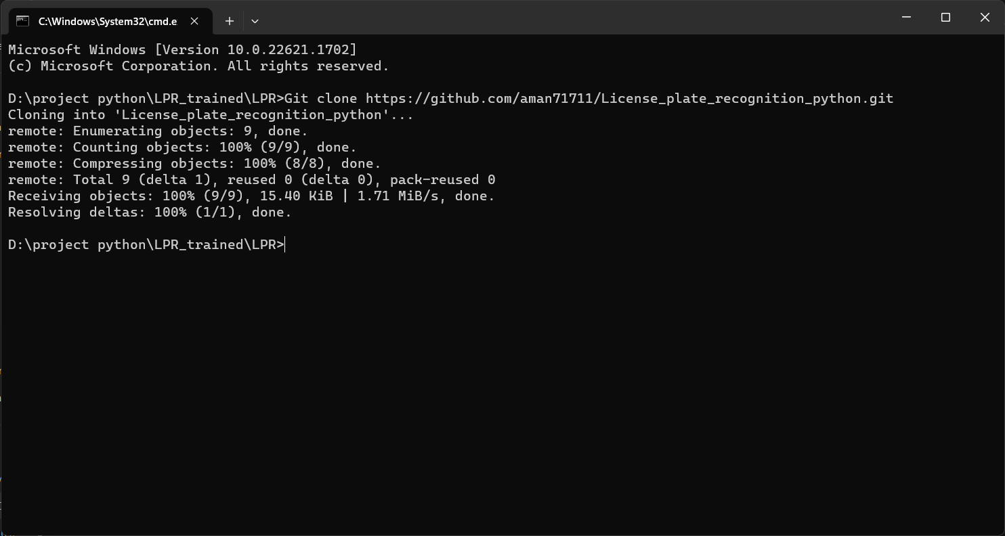
Cd LPR_trained\LPR

Step.2) Installing All necessary Modules
Pip install -r requirements.txt
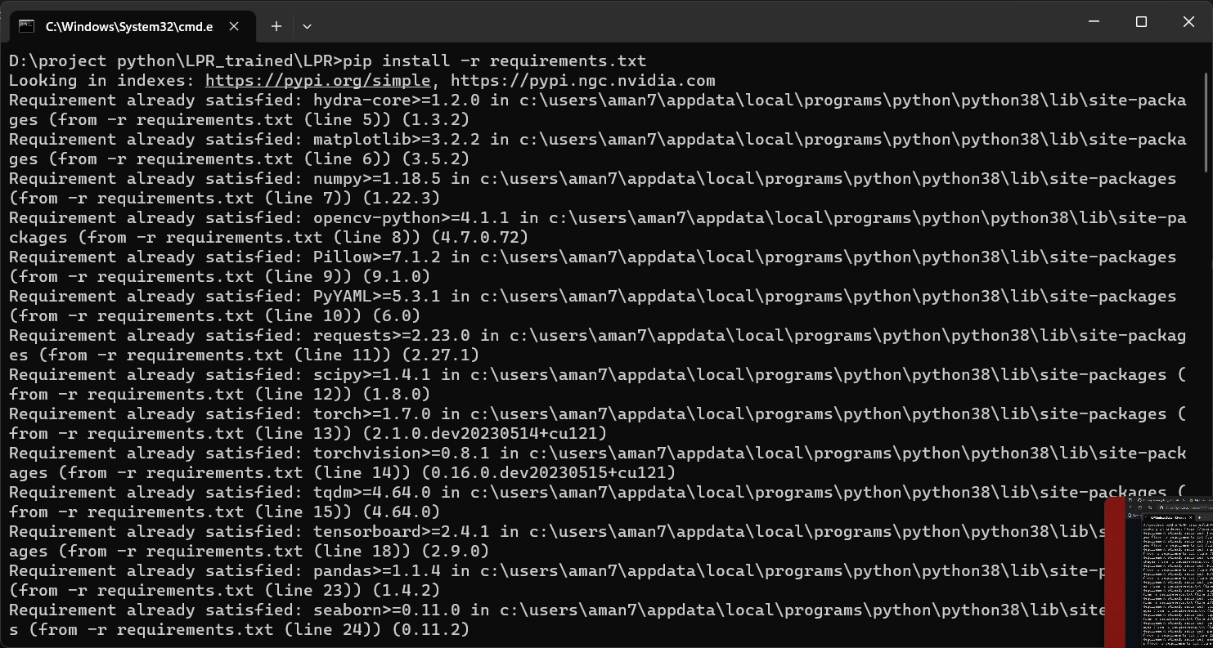

Step.3) Change the directory according to Your Location in predict.py and number_plate.py
Step.4) To run the project

For Webcam:
python number_plate.py
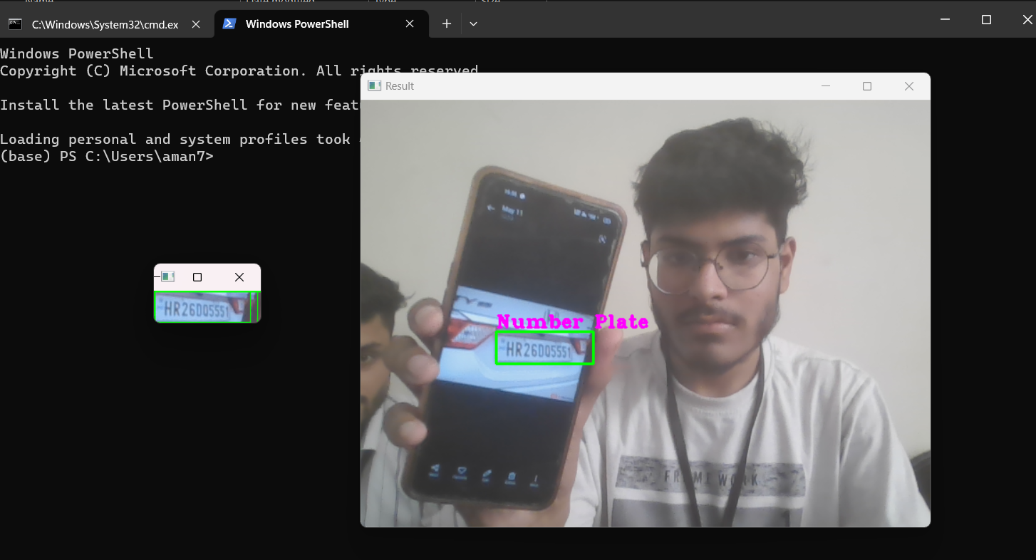

Save image using key 's'
Images will be saved in "D:\project python\LPR_trained\LPR\runs\detect\cam"

For any image:

python predict.py model='best.pt' source="path of image"

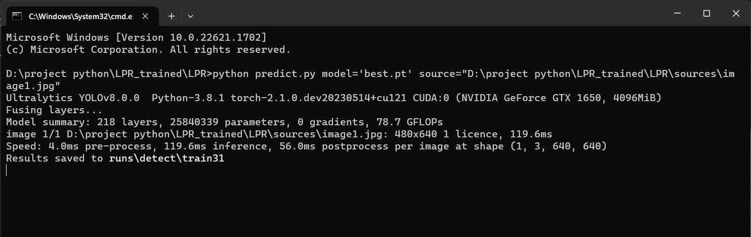
Images will be saved in "D:\project python\LPR_trained\LPR\runs\detect\train"
example: -
python predict.py model='best.pt' source="D:\project python\LPR_trained\LPR\sources\image1.jpg"

For any video:
python predict.py model='best.pt' source="path of video"

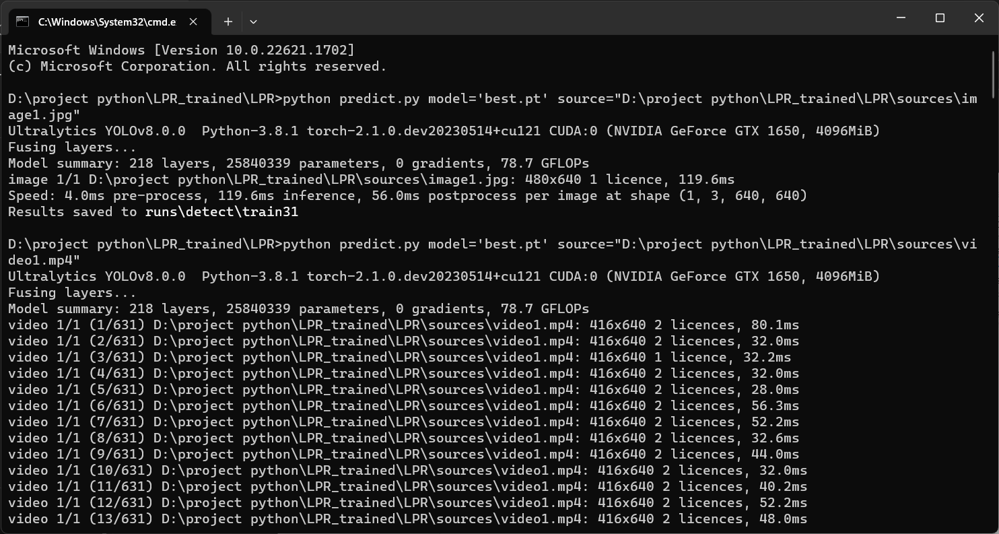
Images will be saved in "D:\project python\LPR_trained\LPR\runs\detect\train"
example: -
python predict.py model='best.pt' source="D:\project python\LPR_trained\LPR\sources\video1.mp4"

